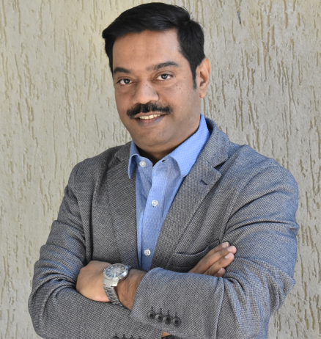

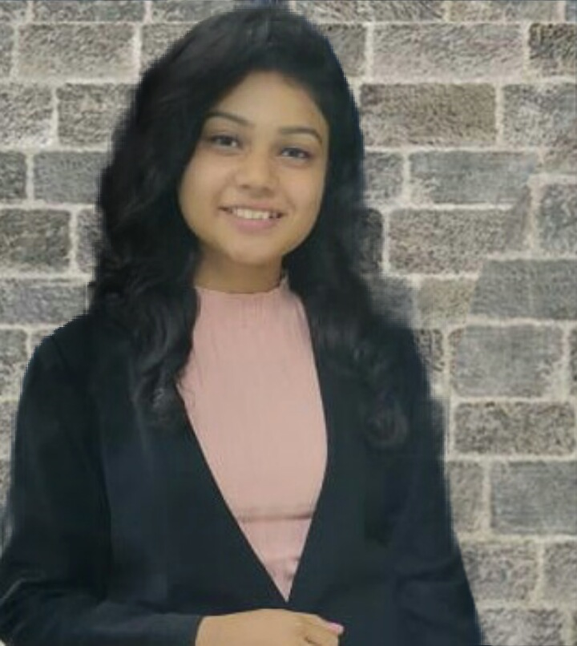

**BFC PUBLICATIONS PVT. LTD.**

**Personal Details**

|  |  |
| --- | --- |
| **Author Name** | Dr. Ravindra Dey |
| **Father Name** | Ashit Dey |
| **Date of Birth** | 15th January, 1974 |
| **Contact No** | 9820306565 |
| **Alternate contact no.** | 9820446619 |
| **e-mail ID** | ravindra.dey@gmail.com |
| **Nominee Name** | Mrs. Sumana Dey |
| **Correspondence Address :**  **Landmark**  **City**  **State**  **Pin Code**  **Country** | 802-803, Sunrise Point,  Neptune Living Point,  LBS Marg, Bhandup West  Near Mangatram Petrol Pump  Mumbai  Maharashtra  400078  INDIA |
| **Co- Author Name** | Ms. Rochelle Pinto |

**BANK DETAILS**

|  |  |
| --- | --- |
| **Account holder’s name** | Ravindra Dey |
| **Account No.** | S. B. A/c. No.  03981140001485 |
| **Bank Name** | HDFC Bank |
| **Branch** | Malad East |
| **IFSC Code** | HDFC0000398 |
| **Pan No.** | ABQPD9060N |

***(Note - *please enclose a photograph of cancelled cheque & PAN Card)***

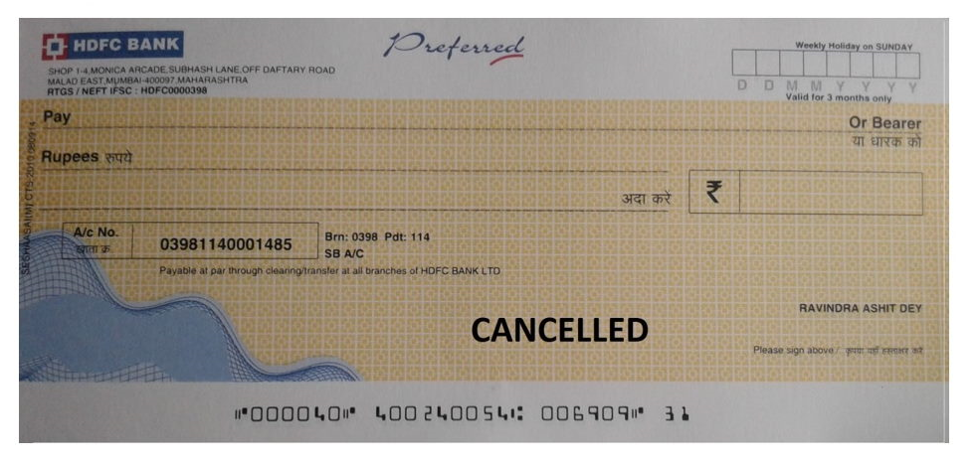

# 

# Book Details

|  |  |
| --- | --- |
| **Book Title** | **Relationship Mysteries**  Unleash the truth to maintain successful relationship |
| **How would you like your name to appear on book?** | Dr. Ravindra Dey  Ms. Rochelle Pinto |
| **Manuscript Language** | English |
| **Book Genre** | Non-Fiction |
| **Number of images (If any)** | Will send the Draft |
| **Manuscript Status (Completed/Proof Read)** | No |
| **Book Size \*** | 5” x 8” |

**Standard Sizes:-**

* 5"x8"
* 6"x9"
* 8.5"x11"

**Cover details**

|  |
| --- |
| **Synopsis - about 500 words (to enable the cover designer to understand the theme of the book and would not be printed on the book)**  A relationship has a very complex nature and we as humans make it even more complicated. When a relationship faces ups and downs, we end it by saying that it’s wasn’t working out. The real question here is “Did you try working it out?” The main reason why a relationship ends is due to problems and this problem tends to pile up as days pass by. This book helps the reader understand that what are some of those minute details that if not taken care of at an early stage end up becoming a problem that becomes difficult to resolve.  This book takes us through the five important relationships that a forms in his lifetime   1. Love   This chapter explains the ‘Love life’ of an individual and what are the problems that could be faced.   1. Friends   This chapter explains the importance of the bond of friendship and how important it is to handle this relationship with care.   1. Family   This chapter explains the different situations that exist between a family and how can such situations be handled.   1. Self   This chapter explains the importance of ‘self-love and demonstrates what could you change within yourself so that you start loving yourself even more.   1. Professional   This chapter explains what are the things that need to be taken care of while being in a professional environment.  In short, this book has been written with the idea of being a self-guide to yourself so that you can be aware of where the problems can occur and how you can fix those problems to save your relationship. |
| **Blurb - about the book** **(a short description of the book to be printed on the back of the cover.)**  A simple question for all of you…How bad is it to lose someone you love the most? I am sure everyone has experienced this feeling at least once. Have you found out the reality of why did such good relations end? If not, then this book is exactly what you need. This book is a tool that helps you to identify where is the problem so that you can stop yourself from losing someone you care about. Also, at the end of every chapter, you will be gifted with some real-life experiences that would give you a clearer vision. Always remember that if a relationship is precious then it’s worth fighting for it. |
| **Author Bio - about 200 words (a short description about you which will be printed on the back cover of the book.)**  Dr. Ravindra Dey is an award-winning Professor, Trainer, Licensed NLP practitioner and Executive Coach in India. He has so far trained thousands of participants in areas of behavioural science, organizational behaviour, organizational development, general management and leadership. He is well-known to bring a change in an individual and in an organization with simplicity and authenticity. His coaching, teaching, consulting and writing inspires people to develop and change and helps an individual to be the beaming light to unleash the inner self.  Rochelle Pinto has always been eager to try new experiences. She has a personality that revolves around her goals and improves her situation. Growing up, she was fascinated with storybooks, and this interest led to some early vision of being able to write a book of her own. She is an MBA graduate specializing in Human Resources and has taken a step ahead towards her dream by becoming the co-author of this book.  To learn more or to get in touch with Dr. Ravindra Dey, visit:  Ravindradey.com |